Whitney Hardy
Task 3.7 Joining Tables of Data
- Write a query to find the top 10 countries for Rockbuster in terms of customer numbers.
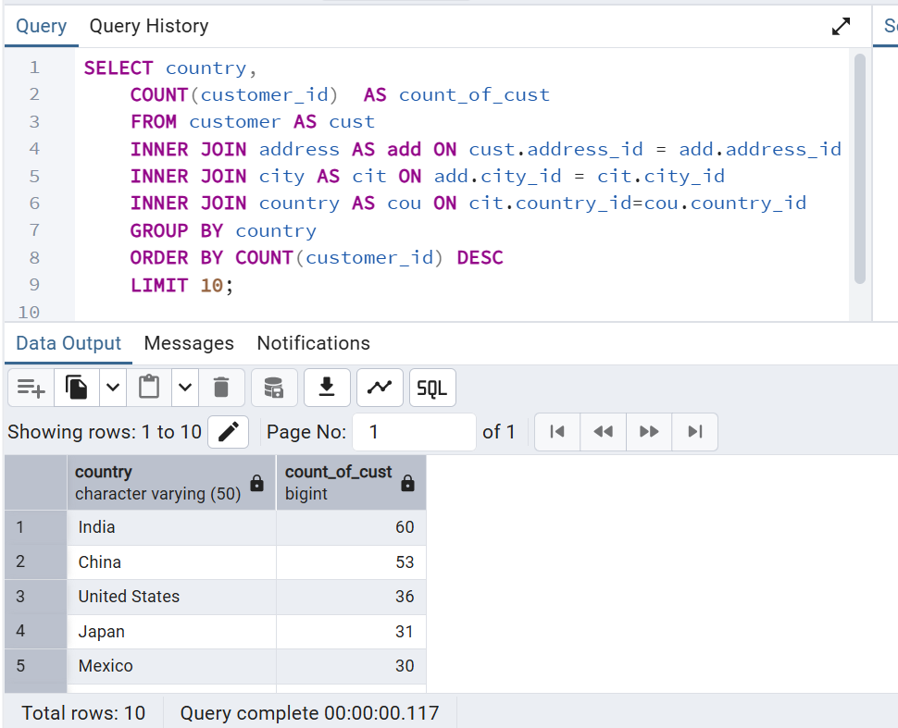
- To write this query I started by reviewing the ERD of the Rockbuster database. Here I was able to see the path to connect all the information I needed. I began at the Customer table went down to address_id, which led me to address table I then went to city_id under the city table I went to country_id which led me to country. Because of all the tables included I choose to use multiple join function. I began my query by selecting country name and counting names of customers. I used the customer table as my main table and using the INNER JOIN function I was able to get relevant information from address, city, and country tables. Lastly, because I only need top ten countries, I used the LIMIT function to limit output to top 10.

- Write a query to identify the top 10 cities that fall within the top 10 countries you identified in step 1.
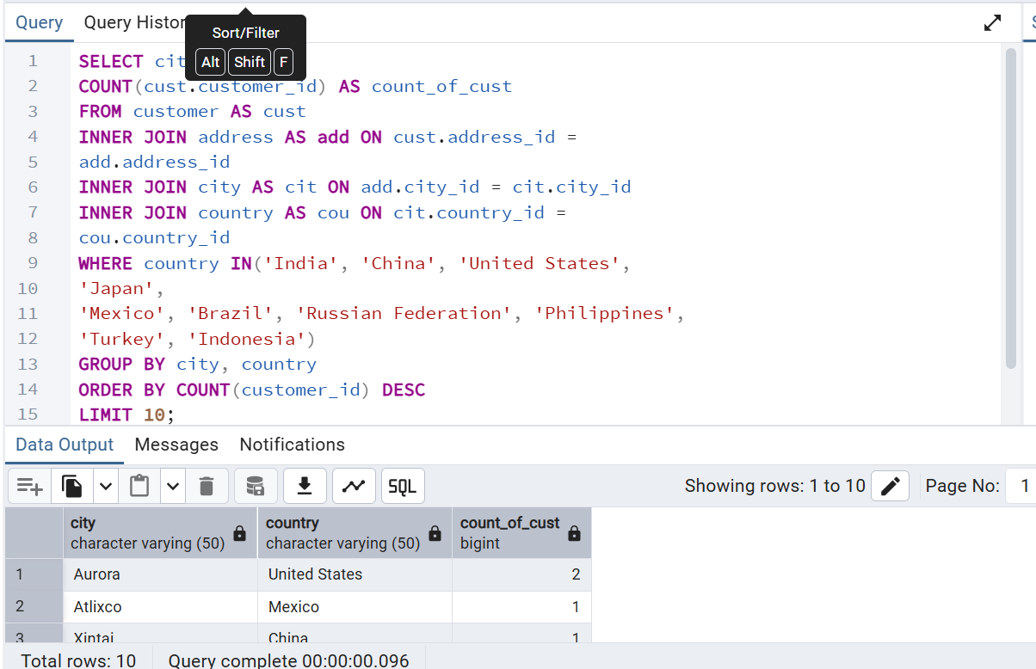
- Now to focus on the cities within the top ten countries identified, I added the WHERE clause within the IN function to my query. Here I included the top ten countries in the line to specify that I wanted the top 10 cities that fall within the top 10 countries. Lastly, I grouped the information (by city, country) so the information is aggregated correctly. Resulting in clear and consistent information from multiple tables.

- Now write a query to find the top 5 customers from the top 10 cities who’ve paid the highest total amounts to Rockbuster.
